Self Management Review

This document contains all the necessary and structured information required for creating your own self-management review. This statement should be removed when you have read it as it is not apart of the template, it is just a discloser statement.

Reporting period 1: Week 1 to Week 4

Meeting agenda & minutes with Client
We do not have any meeting minutes or an agenda with our Client from the first 4 weeks.

Meeting agenda & minutes with Advisor
BDSH Advisor Meeting Minutes (Week 4)
DATE: 06/08/26 | TIME: 12:00PM
LOCATION: T7 Meeting room
ATTENDEES: Clement Swarnappa, Dave Sushames, Matt Baker, Olivia Hey, Sam Davies
APOLOGIES: N/A | NON-ATTENDEE(S): N/A
MEETING LEADER: Dave Sushames, Matt Baker | MINUTES TAKER: Olivia Hey

PROJECT NAME: AI vs Legacy Digital Forensics Tools – A Comparative Efficacy Analysis
PROJECT PURPOSE: Provide an empirical analysis on AI digital forensics technologies
MEETING PURPOSE: Find assistance in preparing the project proposal

AGENDA ITEM: | LED BY (Initials Only): | TIME  ALLOTTED:
State of the project, proposal | MB | 15
Find a new methodology, discuss problem of two competing methodology requirements | DS | 15
Clarification on the client contract | MB | 15
Discuss scope and requirements gathered from our previous meeting with geoff | DS | 15

ACTION ITEM: | DELIVERABLE(S):
Generate meeting minutes, adapt a template, send to clement for signing | Meeting minutes with signature section
Select an appropriate simple methodology that we have used previously | Present methodology

MEETING NOTES:
Proper decorum when organizing meetings
-Agenda should be provided beforehand, meeting minutes after for signing
-Send as word documents in email
-Have meeting 1 and 2 signed before meeting 3
Dave will send proposal document after meeting for clement to review
12:20
Clarification on the client contract, says we should send it to Geoff
We don’t have an advisor to talk to about the forensics side of things
12:30
Methodology discussion
-Hybridization is a possibility
- 1 methodology for testing, 1 for project management
- Kanban?
- Dave needs to make project management documents
-Clement likes using Trello for kanban
- research kanban, update methodology section accordingly
12:40
We can use kanban to improve accountability
Discussion about the review panel
- Provide equivalent work to hours contributed
- Annotate research logs for each piece of work
- Create work for ourselves
- Clarify our titles/roles
Next week there is NO MEETING

Ends at 1pm

DETAILS OF NEXT MEETING: Will be Mon/Tue/Weds the week after next
DATE: N/A | TIME: N/A
LOCATION: T7 Meeting room
MEETING CLOSED: 1pm

SIGNATURES
Name: Clement Swarnappa | Role: Advisor | Signature:
Name: Dave Sushames | Role: Project Manager | Signature: Dave Sushames
Name: Matt Baker | Role: Digital Forensics Technician | Signature: Matt Baker
Name: Sam Davies | Role: Digital Forensics Technician | Signature: Sam Davies
Name: Olivia Hey | Role: Digital Forensics Technician | Signature: Olivia Hey

Gantt Chart
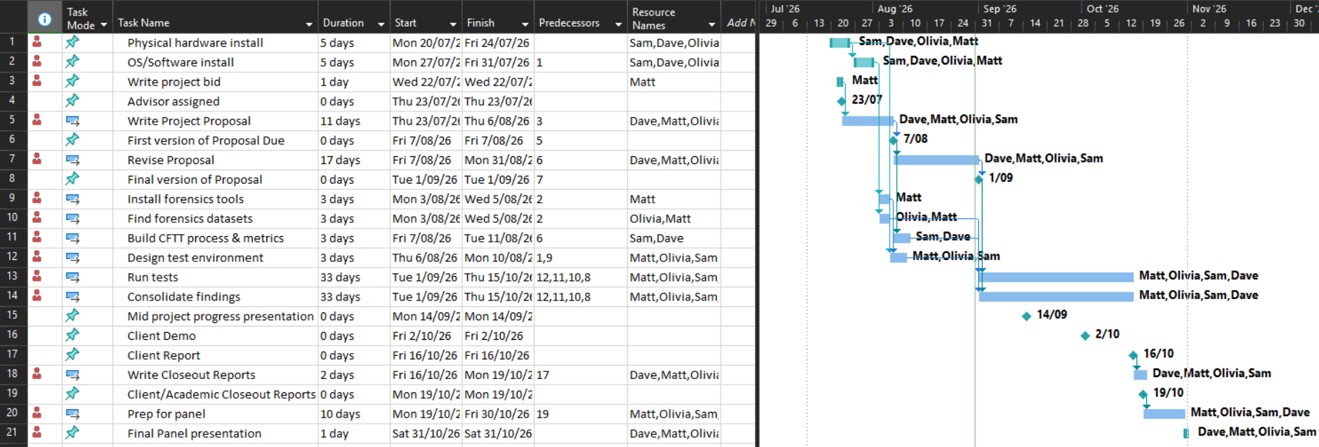

Team Weekly report
Category | Matt Baker | Sam Davies | Olivia Hey | Dave Sushames | Total hours per category
Team meetings | 4 | 4 | 4 | 4 | 16
Client meetings | 45m | 45m | 45m | 45m | 3
Advisor meetings | 1 | 1 | 1 | 1 | 4
Research | 2h 30m | 12h 35m | 8h 10m |  | 23h 15m
Development | 1 | 1 | 1 | 1 | 4
Testing
Sick Leave
Documentation | 8 | 5 | 6h 45m | 10h 30m | 30h 15m
Other |  |  | 30m |  | 30m
Total hours per team member for this week | 16h 45m | 24h 20m | 22h 10m | 17h 15m | 80h 30m
Running total per team member | 46h 15m | 41 | 46 | 40

Team meetings:
Tuesday 10am – 11:30am. Attempted to have a meeting with Geoff, but he wasn’t able to make it, so we discussed our project proposal and who was covering which sections.
Friday 10:15am – 12:45pm. Group call where we went over the proposal and Dave made last minute edits.
Client meetings:
Wednesday 1:30pm-2:15pm. Recorded meeting with Geoff regarding requirements and deliverables.
Advisor meetings:
Thursday 12pm – 1pm. Meeting with Clement discussing what needs to be kept track of, and how the proposal is going. Sent him the current proposal draft for feedback.
Development:
Showing the team the git repository, catching them up on how git works, showing how to commit/push, and resolve basic merge conflicts.
Documentation:
1 hour each for individual logs.
Work on respective parts of proposal.
Olivia: Project Objective
Sam: Project Plan
Matt: Project Personnel
Dave: Timeline, Risk analysis, Gantt chart.
Other:
Olivia spent 30 minutes editing the video footage from Geoff’s interview.

Meeting Minutes
Advisor Meeting Minutes
DATE: 06/08/26 TIME: 12:00PM
Proper decorum when organizing meetings
-Agenda should be provided beforehand, meeting minutes after for signing
-Send as word documents in email
-Have meeting 1 and 2 signed before meeting 3
Dave will send proposal document after meeting for clement to review
12:20
Clarification on the client contract, says we should send it to Geoff
We don’t have an advisor to talk to about the forensics side of things
12:30
Methodology discussion
-Hybridization is a possibility
- 1 methodology for testing, 1 for project management
- Kanban?
- Dave needs to make project management documents
-Clement likes using Trello for kanban
- research kanban, update methodology section accordingly
12:40
We can use kanban to improve accountability
Discussion about the review panel
- Provide equivalent work to hours contributed
- Annotate research logs for each piece of work
- Create work for ourselves
- Clarify our titles/roles
Next week there is NO MEETING
Ends at 1pm

Reporting period 2: Week 10 to Week 12

Meeting agenda & minutes with Client
BHB Meeting Agenda
DATE: 11/09/26 | TIME: 10:00
LOCATION: Remote Meeting via Zoom
ATTENDEES: Geoff Gordon, Dave Sushames, Matt Baker, Olivia Hey, Sam Davies
APOLOGIES: n/a | NON-ATTENDEE(S): n/a
MEETING LEADER: | MINUTES TAKER: Dave Sushames

PROJECT NAME: AI-Enhanced vs Legacy Digital Forensics Tools – A Comparative Efficacy Analysis
PROJECT PURPOSE: Provide an empirical analysis on Ai-augmented digital forensics technologies
MEETING PURPOSE: First Geoff meeting in a while.

AGENDA ITEM: | LED BY (Initials Only): | TIME  ALLOTTED:
1. Apologies | N/A | N/A
2. Action items from previous minutes | N/A | N/A
3:
4:
5:
6:
7:
8: Any other business
9: Assigning next meeting date and time

ACTION ITEM: | DELIVERABLE(S):

MEETING NOTES: Geoff 11/09
1000 Greetings, explaining what the mid project presentation is about
1010 Discussing change in project scope, Bryce’s suggestions
1020 AI is a challenge to get it to work with DF tools, so the answer to the project is probably “no”, we just have to justify that answer.
1030 Limitations of AI, Snellen charts. Context lengths.
1040 Gemma is good because it has a decent context window. Tool looping is an issue (“I’ll read that again. I’ll read that again. I’ll read-“).
1050 Arranging a time for the presentation.
1100 Discussing project management methodologies, Scrum.
1110 Covering weekly hours.
1120 Pro tips on management techniques
1130 New computers. LLMs have different layers, with each layer on a different machine.
1140 Methods of recovering data. Can’t recover data if you destroy the hard drive.
1150 Advice on doing the presentation
Meeting ended 1200

DETAILS OF NEXT MEETING:
DATE: | TIME: 1000
LOCATION: Discord
MEETING CLOSED: 1200

Meeting agenda & minutes with Advisor
BDSH Advisor Meeting Agenda
DATE: 14/09/26 | TIME: 11:00am
LOCATION: On Campus, Level 7
ATTENDEES: Clement Swarnappa, Dave Sushames, Matt Baker, Olivia Hey, Sam Davies
APOLOGIES: N/A | NON-ATTENDEE(S): N/A
MEETING LEADER: Olivia Hey | MINUTES TAKER: Dave Sushames

PROJECT NAME: AI - Augmented vs Legacy Digital Forensics Tools – A Comparative Efficacy Analysis
PROJECT PURPOSE: Provide an empirical analysis on Ai-augmented digital forensics technologies
MEETING PURPOSE: Advisor meeting for mid project presentation

AGENDA ITEM: | LED BY (Initials Only): | TIME  ALLOTTED:
Introductions | N/A | 5m
Progress update | MB | 15m
Discuss Sam hours | SD | 15m
Mid project presentation | OL | 20m

ACTION ITEM: | DELIVERABLE(S):

MEETING NOTES:
1100 Greetings, basics of mid project presentation.
1105 Presentation is all but ready. Who is doing what work? We’re up to Tenmost now.
1110 Making sure everyone has enough work. Documentation, test cases, reporting. Can share the work around, especially scripts and such.
1115 Design science: Artefacts. Check the marking rubric (ask Dax if there isn’t one). People can dig deep into what artefacts are generated/apply to the project. How frequent should they be, eg 3 per sprint? Follow the methodology.
1120 Standardise the test plan. User, UX, utility testing etc.
1125 Discussing Sam + Dave’s logs.
Option 1: Ask Dax to reopen dropbox.
Option2: Matt/Olivia give up their backup dropboxes?
Option 3: Leave it as it. We can keep the logs for the final panel.
1145 Print the rubric before the next meeting, we can go over it to figure out what needs to be done.
Meeting ended 1200

DETAILS OF NEXT MEETING:
DATE: N/A | TIME: N/A
LOCATION: T7 Meeting room
MEETING CLOSED: 12pm

SIGNATURES
Name: Clement Swarnappa | Role: Advisor | Signature: Clement Swarnappa 16/09/26
Name: Olivia Hey | Role: Project Manager | Signature: Olivia Hey
Name: Matt Baker | Role: Digital Forensics Technician | Signature: Matt Baker
Name: Sam Davies | Role: Digital Forensics Technician | Signature: Sam Davies
Name: Dave Sushames | Role: Tester | Signature: Dave Sushames

Gantt Chart
Dave update the Gantt Chart

Team Weekly Report

